A Minor Project I Report on

Online Travel Marketplace

Submitted in partial fulfillment of the requirements for the degree of Bachelor of Engineering in Software Engineering at Pokhara University

***By***

**AAYUSH PARAJULI PRAKRIYA PARAJULI SWORUP KHADKA**



**Department of Research and Development GANDAKI COLLEGE OF ENGINEERING AND SCIENCE**

Lamachaur, Kaski, Nepal

**(April, 2024)**

A Minor Project I Report on

Online Travel Marketplace

Submitted in partial fulfillment of the requirements for the degree of Bachelor of Engineering in Software Engineering at Pokhara University

***By***

**AAYUSH PARAJULI PRAKRIYA PARAJULI SWORUP KHADKA**

#### Supervisor

**Er. PRATIKSHYA SHRESTHA**



**Department of Research and Development GANDAKI COLLEGE OF ENGINEERING AND SCIENCE**

Lamachaur, Kaski, Nepal

**(April, 2024)**

# ABSTRACT

The Online Travel Marketplace project aims to transform the travel industry in Nepal by empowering travel businesses and enhancing the travel experiences for adventure seekers and cultural enthusiasts. The project will enhance the travel experiences of explorers visiting Nepal by providing an intuitive web-based platform that simplifies and streamlines the booking of travel experiences. Our web-based platform will curate authentic local experiences, offering transparent pricing and a streamlined booking process. By democratizing access to the online booking space, we will empower businesses and provide travellers with a wider range of unique and enriching experiences

# TABLE OF CONTENTS

ABSTRACT i

Chapter 1 1

INTRODUCTION 1

* 1. Background 1
  2. Problem Statement 1
  3. Objectives 1
  4. Implications 2

Chapter 2 3

LITERATURE REVIEW 3

Chapter 3 5

TOOLS AND METHODOLOGY 5

* 1. Required Tools 5
  2. Methodology 5
  3. UML Diagrams 6

Chapter 4 14

EXPECTED RESULTS 14

* 1. Expected Outcome 14

Chapter 5 15

FINDINGS, RESULTS & ANALYSIS 15

5.1 Test Case Report/Result 15

5.2 Key Screenshots/Output 16

5.3 Analysis 21

Chapter 6 22

CONCLUSION & RECOMENDATIONS 22

6.1 Conclusion 22

6.2 Recommendations 22

Bibliography 23

## List of Figures

Figure 3.2.1: Waterfall Model 6

Figure 3.3.1.1: Use Case Diagram 7

Figure 3.3.2.1: ER Diagram 11

Figure 3.3.3.1: System Sequence Diagram for Login 12

Figure 3.3.3.2: System Sequence Diagram for Booking 12

Figure 3.3.3.3: System Sequence Diagram for Creating Package 13

Figure 5.2.1: Register Page 16

Figure 5.2.2: List Service Page 17

Figure 5.2.3: Footer 17

Figure 5.2.4: Home Page for User 18

Figure 5.2.5: Home Page for Business 18

Figure 5.2.6: View Listed Package 19

Figure 5.2.7: View Bookings 19

Figure 5.2.8: Browse Travel Packages with Search & Sort 20

Figure 5.2.9: Leave a Review 21

## List of Tables

Table 2.1: Comparision Table 4

Table 5.1.1: Test Cases Table 15

### Background

## Chapter 1 INTRODUCTION

The tourism industry is a vital contributor to Nepal's economy, generating employment and showcasing the country's stunning natural beauty and rich cultural heritage. However, the current travel booking landscape faces several challenges, hindering its growth and impacting both travellers and local businesses. Smaller travel businesses struggle to compete with larger corporations due to their limited online presence. Meanwhile, travellers often encounter confusing and inaccurate information regarding prices, inclusions, local regulations, and travel experiences. The Online Travel Marketplace (OTM) is designed to address these critical challenges and revolutionize the online travel booking landscape in Nepal. (Nepal Tourism Board, 2023)

### Problem Statement

Despite possessing unique insights and local expertise, travel businesses in Nepal struggle to compete effectively in the online sphere. Limited financial resources restrict their ability to develop robust online presences and reach potential customers, creating an uneven playing field dominated by larger corporations. travellers venturing to Nepal often encounter a frustrating lack of transparency in the booking process. Opaque pricing, unclear inclusions, and unreliable information about local regulations and travel experiences lead to confusion, erode trust, and ultimately diminish the quality of the travel experience. The combined effect of these challenges creates a disadvantageous environment for both travellers and local businesses in Nepal's tourism industry. (Kim, S., & Lee, G., 2019)

### Objectives

The main objective of this project is:

* To develop web application to make online travel booking accessible to travel businesses in Nepal.

### Implications

The Online Travel Marketplace project carries profound implications for Nepal's travel industry and its stakeholders. By democratizing the online travel booking space, it opens doors for local businesses, particularly small and medium-sized enterprises, to compete on a level playing field, fostering their growth. This empowerment extends to travellers who will gain access to a curated selection of travel experiences, offering them more fulfilling and personalized journeys, allowing them to explore Nepal in a more meaningful and informed way. The project also addresses long-standing issues of transparency and trust within Nepal's travel industry. By eliminating opacity in the booking process, it seeks to build trust between travellers and service providers. (Smith, J., 2018)

## Chapter 2 LITERATURE REVIEW

In the dynamic realm of the travel industry, we derive valuable insights from influential online travel booking platforms such as Booking.com, MakeMyTrip, and eSewa. These industry giants offer a plethora of travel products and services, constituting a foundation for the Online Travel Marketplace' venture. However, it's crucial to recognize their strengths and the areas where innovation is imperative.

|  |  |  |
| --- | --- | --- |
| **Booking.com:** | | Booking.com is a global stalwart established in 1996, commanding a |
| extensive portfolio of travel products, encompassing over 28 million accommodations worldwide. Nonetheless, Booking.com's registration and listing procedures may pose challenges for smaller Nepali travel businesses. This platform also struggles to cater to the unique needs and preferences of travellers exploring Nepal. (Booking.com, 2023) | | |
| **MakeMyTrip:** | | MakeMyTrip is India's leading online travel booking platform since |
| 2000, offering a comprehensive array of services, from flights and hotels to tours and car rentals. Similarly, smaller travel businesses in Nepal encounter hurdles during the registration and listing process on MakeMyTrip. Adapting to Nepal's distinctive local travel landscape can present ongoing challenges. (MakeMyTrip, 2023) | | |
| **eSewa:** | eSewa, a pioneer in the Nepali digital payments landscape, established in 2009, | |
| has become synonymous with convenience and security. Its vast network of partnered businesses, including airlines, hotels, and tour operators, allows users to seamlessly book and pay for travel experiences online. However, it's essential to acknowledge that eSewa does not operate as an open marketplace, primarily offering its trekking and tour services, limiting the platform's diversity of offerings and hindering smaller local enterprises. (eSewa, 2023)  The reviewed models, Booking.com and MakeMyTrip, falter in providing the distinct and localized experiences that travellers in Nepal desire, leaving a void in the market. Additionally, they pose significant barriers for small and medium-sized Nepalese travel businesses. eSewa's lack of an open marketplace further restricts the range of available travel experiences. In contrast, Online Travel Marketplace emerges as a transformative solution to bridge these gaps and meet the unique demands of Nepal's travellers and businesses. | | |

***Table 2.1: Comparision Table***

|  |  |  |  |  |
| --- | --- | --- | --- | --- |
| Features | Booking.com | MakeMyTrip | eSewa | Online Travel Marketplace |
| Login/Register | ✔ | ✔ | ✔ | ✔ |
| Online payment | ✔ | ✔ | ✔ | ✖ |
| Variety of travel packages | ✔ | ✔ | ✖ | ✔ |
| Localized experiences | ✖ | ✖ | ✔ | ✔ |
| Vouchers | ✔ | ✔ | ✔ | ✖ |
| Open Marketplace | ✖ | ✖ | ✖ | ✔ |

## Chapter 3

# TOOLS AND METHODOLOGY

### Required Tools

To develop the application, we will require various tools essential for the project. Our project will use the following tools:

|  |  |  |
| --- | --- | --- |
|  | **JavaScript:** | For Client-side scripting. |
|  | **HTML and CSS:** For Frontend design. | |
|  | **Draw.io:** For diagramming software. | |
|  | **Node.js:** For Server-side scripting. (Node.js, 2023) | |
|  | **MySQL database:** For managing system databases. (MySQL, 2023) | |
|  | **LibreOffice Writer:** For writing proposals and reports. | |
|  | **Figma:** For UI/UX design. | |
|  | **Git/Github:** For version control. (GitHub, 2023) | |

### Methodology

Every software development methodology approach acts as a basis for applying specific frameworks to develop and maintain software. Several software development approaches have been used since the origin of information technology.

.

|  |  |  |
| --- | --- | --- |
| The online travel marketplace web application system implements the | **Waterfall model** |  |
| It is compatible with the size of our project and suited for the available time frame. | | |

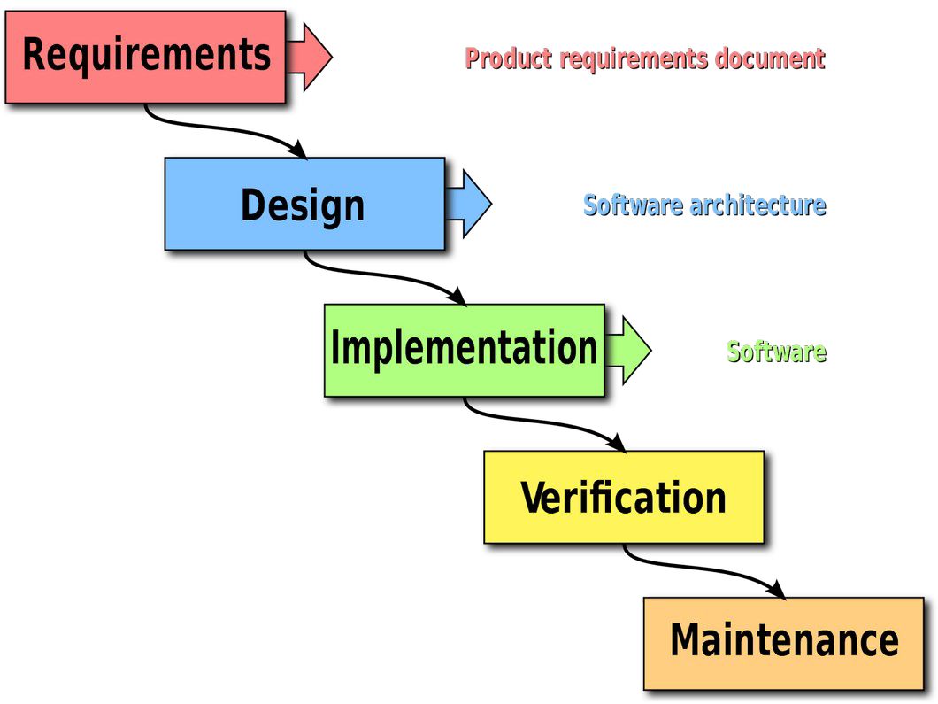

***Figure 3.2.1: Waterfall Model***

(Wikipedia, 2023)

### UML Diagrams

#### Use Case Diagram

A use case diagram is a way of visualizing the requirements and functionalities of a system. It shows the actors (users or roles) and the use cases (actions or goals) they can perform in the system.

The high-level use case diagram of our project is:

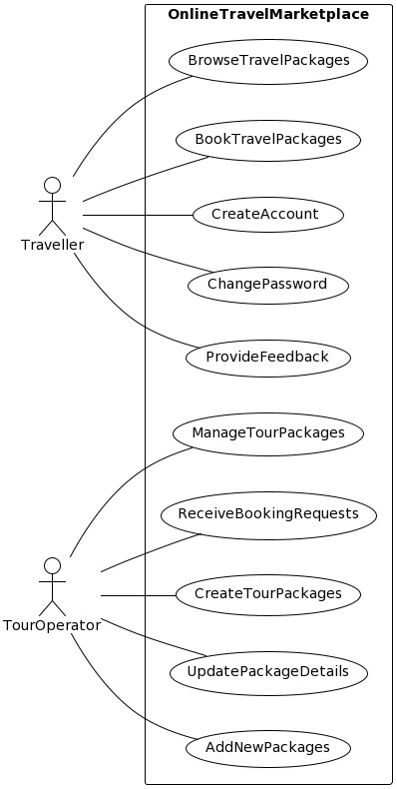

***Figure 3.3.1.1: Use Case Diagram***

In this diagram, the system is an online travel marketplace that allows tour operators and travellers to interact with each other.

**Actors:**

|  |  |  |  |
| --- | --- | --- | --- |
|  | **Traveller:** | Searches for and books travel packages. | |
|  | **Tour Operator:** | | Creates, manages, and updates travel packages. |

**Use Cases:**

**Use Case UC1: Browse Travel Packages**

Traveller

The Traveller initiates the process of searching and browsing travel packages on the online marketplace.

The Traveller has access to the online marketplace.

**Postcondition:** The Traveller views a list of matching travel packages.

**Precondition:**

**Description:**

**Primary Actor:**

**Use Case UC2: Book Travel Packages**

|  |  |  |  |
| --- | --- | --- | --- |
| **Primary Actor:** | | | Traveller |
|  | | | |
| **Description:** | The Traveller selects and books a travel package. | | |
|  | | | |
| **Precondition:** | | The Traveller has browsed travel packages and selected one. | |
|  | | | |
| **Postcondition:** | | The Traveller completes the booking and receives a confirmation. | |

**Use Case UC3: Create Account**

|  |  |  |  |
| --- | --- | --- | --- |
| **Primary Actor:** | | | Traveller |
|  | | | |
| **Description:** | The Traveller creates an account. | | |
|  | | | |
| **Precondition:** | | The Traveller does not have an existing account. | |
|  | | | |
| **Postcondition:** | | The Traveller creates an account and logs in. | |

**Use Case UC4: Change Password**

Traveller

The Traveller changes their account password.

The Traveller has an existing account and is logged in.

**Postcondition:** The Traveller changes their password and receives a confirmation.

**Precondition:**

**Description:**

**Primary Actor:**

**Use Case UC5: Provide Feedback**

|  |  |  |  |
| --- | --- | --- | --- |
| **Primary Actor:** | | | Traveller |
|  | | | |
| **Description:** | The Traveller provides feedback on their experience with the online | | |
| marketplace. | | | |
| **Precondition:** | | The Traveller has booked a travel package and completed their trip. | |
|  | | | |
| **Postcondition:** | | The Traveller submits their feedback. | |

**Use Case UC6: Manage Tour Packages**

|  |  |  |  |
| --- | --- | --- | --- |
| **Primary Actor:** | | | TourOperator |
|  | | | |
| **Description:** | The TourOperator updates, and deletes travel packages. | | |
|  | | | |
| **Precondition:** | | The TourOperator has an existing account and is logged in. | |
|  | | | |
| **Postcondition:** | | The TourOperator manages their travel packages. | |

**Use Case UC7: Receive Booking Requests**

|  |  |  |
| --- | --- | --- |
| **Primary Actor:** | | TourOperator |
|  | | |
| **Description:** | The TourOperator receives booking requests from travellers for their travel | |
| packages. | | |

|  |  |
| --- | --- |
| **Precondition:** | The TourOperator has an existing account and is logged in. The |
| TourOperator has created at least one travel package. The traveller has booked a travel package offered by the TourOperator. | |
| **Postcondition:** | The TourOperator receives the booking request. |

**Use Case UC8: Create Tour Packages**

|  |  |  |  |
| --- | --- | --- | --- |
| **Primary Actor:** | | | TourOperator |
|  | | | |
| **Description:** | The TourOperator creates new travel packages and adds them to the online | | |
| marketplace. | | | |
| **Precondition:** | | The TourOperator has an existing account and is logged in. | |
|  | | | |
| **Postcondition:** | | The TourOperator creates a travel package and receives a confirmation. | |

**Use Case UC9: Update Package Details**

|  |  |  |  |
| --- | --- | --- | --- |
| **Primary Actor:** | | | TourOperator |
|  | | | |
| **Description:** | The TourOperator updates the details of existing travel packages. | | |
|  | | | |
| **Precondition:** | | The TourOperator has an existing account and is logged in. The | |
| TourOperator has created at least one travel package. | | | |
| **Postcondition:** | | The TourOperator updates a travel package and receives a confirmation. | |
|  | | | |

#### ER Diagram

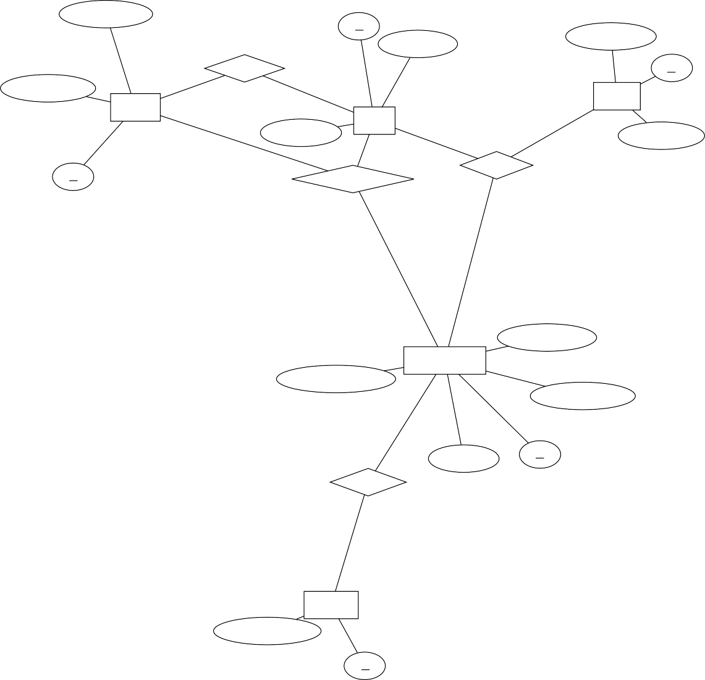

BookingDate

id

UserEmail

RatingScore

Makes

id

BookingTime

N

1

Review

Booking

1

UserName

User

1

1

N

ReviewText

id

Gives

Participates

N

1

PackagePrice

TravelPackage

PackageLocation

PackageName

1

Category

id

Offers

M

Business

BusinessName

id

***Figure : 3.3.2.1 ER Diagram***

An ER diagram is a graphical representation of the structure and relationships of a database. It consists of entities, which are the objects or concepts that store data, and relationships, which are the associations or interactions between the entities. Chen’s ER diagram notation is a graphical method of representing the structure and relationships of a database. It was developed by Peter Chen in 1976 and is widely used in database design and modeling. The above figure is drawn using Chen's Notation.

#### System Sequence Diagrams

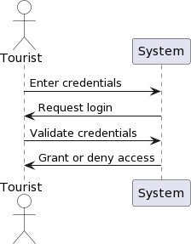A sequence diagram is a type of interaction diagram because it describes how and in what order a group of objects works together. These diagrams are used by software developers and business professionals to understand requirements for a new system or to document an existing process. Sequence diagrams are sometimes known as event diagrams or event scenarios.

***Figure 3.3.3.1: System Sequence Diagram for Login***

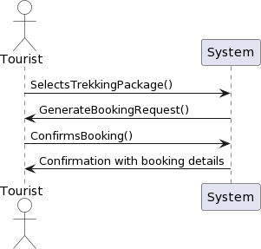

***Figure 3.3.3.2: System Sequence Diagram for Booking***

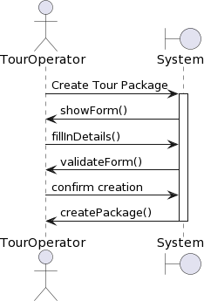

***Figure 3.3.3.3: System Sequence Diagram for Creating Package***

## Chapter 4 EXPECTED RESULTS

* 1. **Expected Outcome**

|  |  |
| --- | --- |
| The expected results indicate not only the success of the online travel marketplace project but also its impact on the tourism industry, traveler satisfaction, and digital innovation in the evolving travel landscape. | |
| **Expected Outcomes:** |  |

|  |  |  |
| --- | --- | --- |
| 1. | **Market Expansion:** | Increased visibility and exposure for local travel businesses, |
|  | reaching out to a wider customer base in Nepal and beyond. | |
| 2. | **Revenue Growth:** Increase in bookings and revenue due to the variety and | |
|  | quality of the travel packages offered on the online platform. | |
| 3. | **Customer Satisfaction:** Improved user experience leading to higher satisfaction | |
|  | and retention. | |
| 4. | **Operational Efficiency:** Simplified booking processes contributing to efficient | |
|  | operations. | |

# Chapter 5

# ****FINDINGS, RESULTS & ANALYSIS****

**5.1 Test Case Report/ Result**

The testing phase of the Online Travel Marketplace project was comprehensive, covering various functionalities such as account creation, package booking, and feedback submission. Each test case was meticulously documented, revealing a high success rate with minor discrepancies that were promptly addressed. The detailed test case report underscores the robustness of the platform.

***Table 5.1.1 Test Cases Table***

| **S.No.** | **Test Cases** | **Expected Result** | **Result** | **Remark** |
| --- | --- | --- | --- | --- |
| 1 | Account Creation | Successful registration and login capability for users. | Pass | Registration and login were seamless, with no issues reported. |
| 2 | Package Booking | Users can book travel packages with confirmation. | Pass | Booking process was intuitive, and users received clear confirmations. |
| 3 | Feedback Submission | Users can submit feedback on their travel experience. | Pass | Feedback mechanism was user-friendly, and responses were positive. |
| 4 | Password Change | Users can change their password securely. | Pass | Password change feature was secure and easy to use. |
| 5 | Package Listing | Tour operators can list new travel packages. | Pass | Listing new packages was straightforward and well-integrated. |
| 6 | Booking Management | Tour operators can manage bookings effectively. | Pass | Management tools were efficient and provided good system support. |

This table reflects the successful implementation of the Online Travel Marketplace's key features, ensuring a positive user experience and operational efficiency for tour operators.

* 1. **Key Screenshots/Output**

Key interfaces of the platform, including the homepage, booking page, and user dashboard, were captured in screenshots. These visuals not only showcase the application’s user-friendly design but also confirm the successful implementation.

***Figure 5.2.1 Register Page***

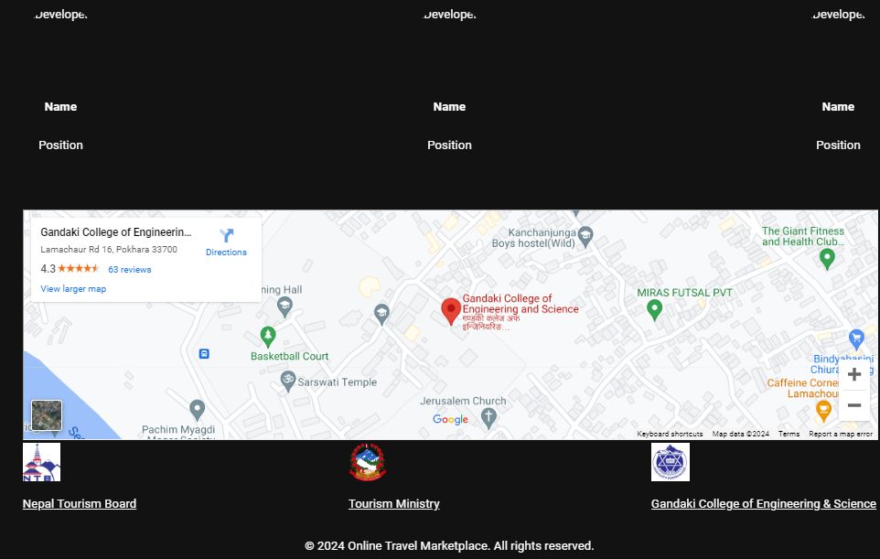

***Figure 5.2.3 Footer***

***Figure 5.2.2 List Service Page***

***Figure 5.2.4 Home Page for User***

***Figure 5.2.5 Home Page for Business***

***Figure 5.2.6 View Listed Packages***

***Figure 5.2.7 View Bookings***

***Figure 5.2.8 Browse Travel Packages with Search & Sort***

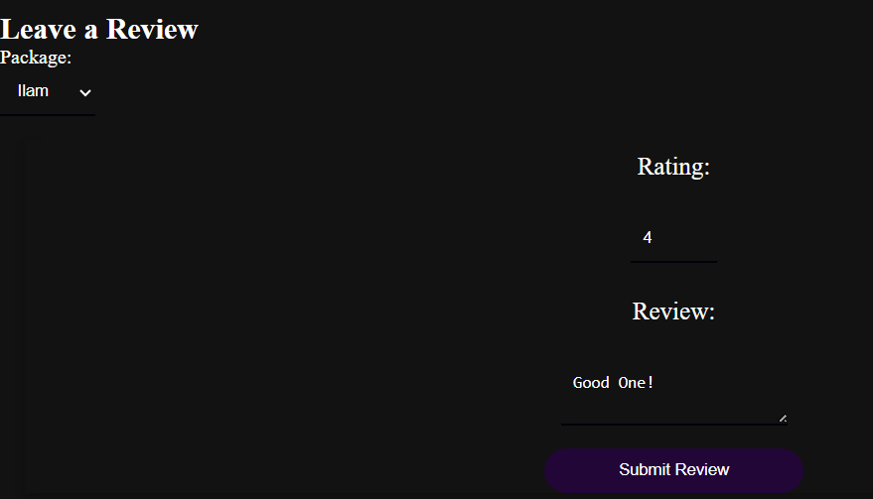

***Figure 5.2.9 Leave a Review***

**5.3 Analysis**

Analysis of the test results indicates a strong correlation between the platform’s performance and the project’s objectives. The seamless interaction between users and the system validates the effectiveness of the implemented methodologies and tools.

# ****Chapter 6****

# ****CONCLUSION & RECOMENDATIONS****

**5.1 Conclusion**

The Online Travel Marketplace has made significant strides in revolutionizing Nepal’s travel industry. By facilitating a more transparent and accessible booking process, the project has achieved its objectives and contributed to the empowerment of local businesses and the enhancement of travellers’ experiences.

**5.2 Recommendation**

For future iterations, it is recommended to explore advanced features such as AI-driven personalization, integration with social media for marketing, and partnerships with local stakeholders to further enrich the travel offerings. Continuous user feedback and market analysis will be crucial in guiding these improvements.

## Bibliography

*Booking.com. (n.d.). "World's #1 Choice for Travels" Retrieved October 8, 2023, from*

[*https://www.booking.com*](https://www.booking.com/)

*eSewa. (n.d.). "Pioneer in Nepali Digital Payments." Retrieved October 10, 2023, from*

*Smith, J. (2018). "Revolutionizing the Tourism Industry: A Comprehensive Review of*

*Online Travel Marketplaces.*" *Journal of Tourism Research, 25(3), 123-145.*

*Online Travel Marketplaces." Journal of Tourism Research, 25(3), 123-145 Online Travel Marketplaces." Journal of Tourism Research, 25(3), 123-145 Online Travel Marketplaces." Journal of Tourism Research, 25(3), 123-145 Online Travel Marketplaces." Journal of Tourism Research, 25(3), 123-145*

*Sized Travel Businesses." Journal of Business and Technology, 14(4), 210-230*

*Kim, S., & Lee, G. (2019). "Impact of Online Travel Agencies on Small and Medium-*

[*https://www.esewa.com.np*](https://www.esewa.com.np/)

*GitHub. (n.d.). Retrieved October 10, 2023, from* [*https://www.github.com*](https://www.mysql.com/)

*October 9, 2023, from* [*https://www.makemytrip.com*](https://www.makemytrip.com/)

*MakeMyTrip. (n.d.). "India's Leading Online Travel Booking Platform." Retrieved*

*MySQL. (n.d.). Retrieved October 10, 2023, from* [*https://www.mysql.com*](https://www.mysql.com/)

*October 10, 2023, from* [*https://ntb.gov.np/*](https://ntb.gov.np/)

*Nepal Tourism Board. (n.d.). "Official Website of Nepal Tourism Board." Retrieved*

*Node.js. (n.d.). Retrieved October 10, 2023, from* [*https://www.nodejs.org/*](https://www.nodejs.org/)

*Wikipedia. (n.d.). Retrieved October 10, 2023, from* [*https://www.wikipedia.org/*](https://www.nodejs.org/)